

**YEAR 12 UNIT 4**

**HUMAN BIOLOGY**

**TEST 5**

**Hominin Evolutionary Trends**

|  |  |  |
| --- | --- | --- |
| **Name:** | **Teacher:**  Ms Langford-Davis | **Mark:** |

**Assessment Type:** Test

**Conditions:**

Time for the task: 55 minutes

**Task Weighting: 5%**

|  |  |  |
| --- | --- | --- |
| **Sections** | **Marks Allocation** | **Your Total** |
| **1 - Multiple Choice** | 14 |  |
| **2 – Short Answer** | 31 |  |
| **3 – Extended Response** | 10 |  |
| **TOTAL** | 55 |  |

**Section One: Multiple-choice 14 Marks**

Circle the correct answer to the following questions.

1. The main difference between Neanderthals and Cro-Magnon man is:
2. prominence of the brow ridge.
3. shape of the jaw.
4. forward facing eyes.
5. presence of sagittal crest.
6. The Australopithecine dentition is characterised by small incisors and canines, but huge premolars. From this dental pattern it could be deduced that:
7. the cranial capacity has greatly increased.
8. hands were used instead of teeth as defence weapons.
9. large quantities of food were eaten.
10. the diet consisted of plant and animal material.

Question 3 refers to the diagram below, which depicts primate skulls.

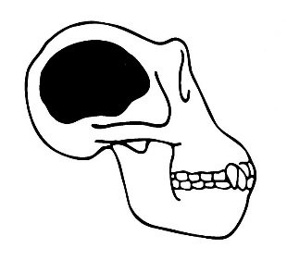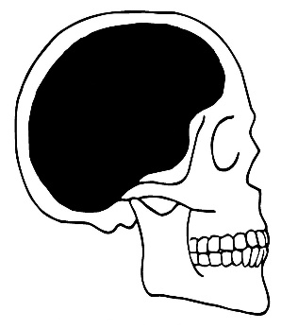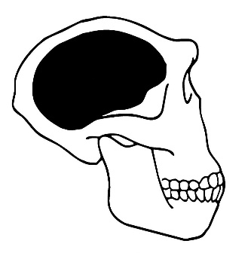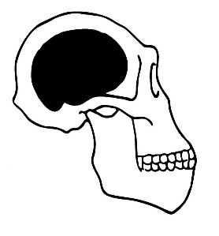

1 2 3 4

1. Which of the following would be the most likely evolutionary sequence towards Homo sapiens?
   1. 3 4 2 1
   2. 3 2 4 1
   3. 4 3 2 1
   4. 4 2 3 1
2. Identify the correct comparisons between Ponginae and Homininae:

|  |  |  |
| --- | --- | --- |
| **CHARACTERISTIC** | **Ponginae** | **Homininae** |
| 1. Elongated pelvis | present | absent |
| 1. Dental diastema | absent | present |
| 1. Carrying angle | present | absent |
| 1. Transverse arch in foot | present | present |

1. Upright bipedal locomotion is thought to have first arisen in hominids:
2. at least 10 million years ago.
3. between 3 and 5 million years ago.
4. between 1 and 2 million years ago.
5. less than 1 million years ago.
6. The following statements relate to primate evolutionary trends.

(i) an increase in the relative size of the cerebral cortex

(ii) a shift from reliance on sight to reliance on olfaction

(iii) an increase in the mobility of digits

(iv) a lengthening of the gestation period

(v) a decrease in the dependence of offspring on parents

(vi) a reduction in the number of teeth

Which of the above statements are correct?

1. (i), (ii), (iii) and (vi)
2. (i), (iii), (iv), and (vi)
3. (ii), (iii), (iv) and (v)
4. (i), (iii), (v) and (vi)
5. In view of the fragmentary fossil evidence of primates, the statement which best fits the evolutionary theory of the origins of man is:
6. man is the descendant of the monkeys.
7. man is a descendant of the apes.
8. man and monkey are descendants of a common ancestor.
9. man and monkeys do not share a common evolutionary development.
10. Homo sapiens throughout the world are considered by scientists to belong to a single species because they all:
11. make use of manufactured tools.
12. can interbreed to produce viable offspring.
13. have binocular colour vision.
14. use language and symbols as a means of cultural transmission.

Question 9 refers to the pictures below:

|  |  |
| --- | --- |
| Orangutan jaw  Jaw P | Human jaw 1  Jaw Q |

1. Which of the following statements about the lower jaws shown in the pictures is correct?
2. Jaw P belongs to a modern human because the dental arcade has a parabolic shape.
3. Jaw Q belongs to a Ponginae because the teeth are of an even size.
4. Jaw P belongs to a Ponginae because of the presence of a diastema.
5. Jaw Q belongs to a modern human because there are more molars present than in Jaw P.

1. Which of the following pairs of hominins and their culture is correctly matched?
2. Homo neanderthalensis – first to farm crops and animals
3. Homo habilis – first to bury their dead
4. Cro magnon – first to have spiritual beliefs
5. Home erectus – first to make fire
6. The following image was found in a cave.

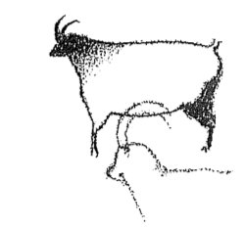

Which hominin group would have been the first to create this?

1. Cro Magnon
2. Homo erectus
3. Australopithecines
4. Neanderthal man

**The next TWO questions refer to the following tools that were unearthed in a variety of locations. They are not drawn to scale.**

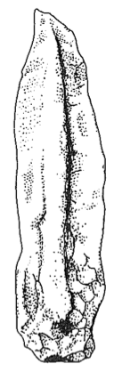 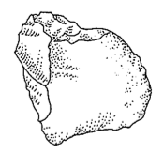 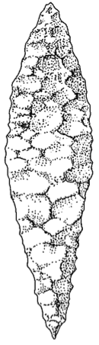 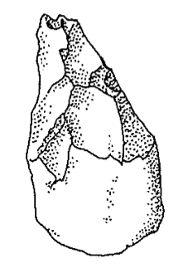

A B C D

1. In which order would these tools have been developed?
2. D B A C
3. B D C A
4. A B D C
5. C D B A
6. Tool D would have been made by:
7. Homo habilis
8. Cro magnon man
9. Neanderthal man
10. Homo erectus
11. Which of the following correctly matches the hominin to the associated lifestyle change?
12. Homo habilis – food sharing, Homo erectus – cave murals
13. Homo habilis – use of fire, Homo sapiens – cooperative hunting
14. Homo neanderthalensis – development of agriculture, Australopithecines – home bases
15. Homo habilis – food sharing, Homo erectus – cooperative hunting

**Section Two: Short answer 31 marks**

Write your answers in the spaces provided.

**Question 1**

As hominins evolved their cranial capacity gradually increased. For each of the three functional areas of the cerebral cortex listed below, explain **one** advantage an increased brain size gave to early *Homo sapiens* to enable them to survive in their environment.

|  |  |
| --- | --- |
| **Functional area of cerebral cortex** | **Advantage** |
| Association |  |
| Motor |  |
| Sensory |  |

(3 marks)

**Question 2**

The drawings below show different sets of tools found at different archaeological sites associated with different human evolutionary groups.



# Set 1 Set 2 Set 3 Set 4 Set 5 Set 6 Set 7

1. Which set of tools is the oldest? Explain your choice.

(2 marks)

1. What does Set 4 indicate about the uses of different tools?

(2 marks)

1. What trends in tool development are shown from Set 2 to Set 6?

(2 marks)

**Question 3**

Around 5-6 million years ago, environmental conditions changed in Africa. These changes are believed to have contributed to the appearance of the first hominin individuals.

1. Outline the environmental changes that occurred in Africa

_________________________________________________________________________________________________________________________________________________________________________________________________________________________________

(3 marks)

1. Identify the important hominin characteristic that evolved as a result of these changes and explain 3 advantages this new characteristic provided for hominins in their new environment.

_________________________________________________________________________________________________________________________________________________________________________________________________________________________________

___________________________________________________________________________

(4 marks)

1. Describe five major anatomical adaptations of Hominins and explain why they are important.

|  |  |
| --- | --- |
| **Adaptation** | **Importance** |
|  |  |
|  |  |
|  |  |
|  |  |
|  |  |

(10 marks)

**Question 4**

Archaeologists excavating a site in the Dordogne region of France came across a complete fossilised footprint. Based on its characteristics, they thought it had been made by a species of hominin.

1. Describe **three** characteristics of the footprint that would indicate it had been made by a

species of hominin. ____________________________________________________________________________________________________________________________________________________________________________________________________________________________________________________________________________________________________________

(3 marks)

1. On the basis of tools also found at the site, the archaeologists concluded the footprint belonged to *Homo neanderthalensis*. Describe **two** features of the tools that would provide support for the fossilised footprint belonging to *Homo neanderthalensis*.

_________________________________________________________________________________________________________________________________________________________________________________________________________________________________

(2 marks)

**Section Three: Extended answer 10 MARKS**

The evolution of hominins can be related to certain cultural advances that improved their survival chances. Describe five cultural advances that have characterised hominin evolution, giving consideration to how these advances aided survival.

________________________________________________________________________________________________________________________________________________________________________________________________________________________________________________________________________________________________________________________________________________________________________________________________________________________________________________________________________________________________________________________________________________________________________________________________________________________________________________________________________________________________________________________________________________________________________________________________________________________________________________________________________________________________________________________________________________________________________________________________________________________________________________________________________________________________________________________________________________________________________________________________________________________________________________________________________________________________________________________________________________________________________________________________________________________________________________________________________________________________________________________________________________________________________________________________________________________________________________________________________________________________________________________________________________________________________________________________________________________________________________________________________________________________________________________________________________________________________________________________________________________________________________________________________________________________________________________________________________________________________________________________________________________________________________________________________________________________________________________________________________________________________________________________________________________________________________________________________________________________________________________________________________________________________________________________

(10 marks)